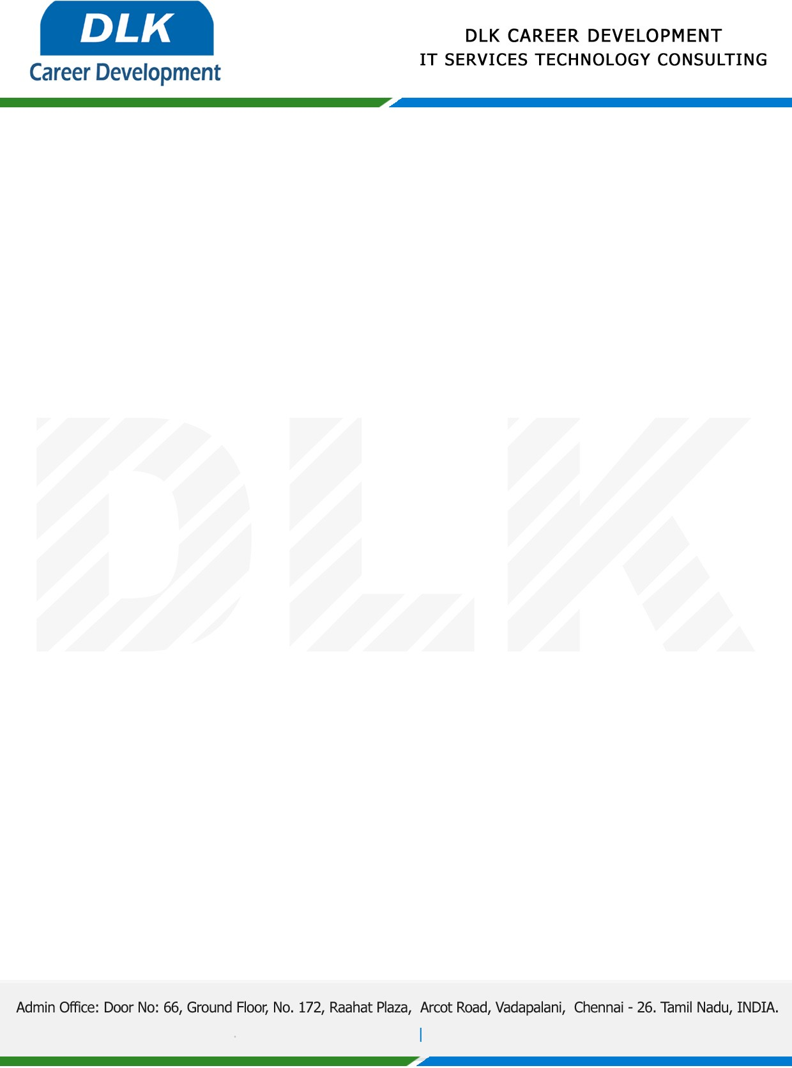

Date: 21 /April / 2023

**To**

Department of BCA-(Computer Application)

Head of Department,

SRM Trichy Arts and Science College

**Sub: Letter of Internship Acceptance**

This is to certify that **RANJANI P** **(REG NO:** **CB20S 262386)** Third year student of has accepted the internship Work duration from **24th April 2023 to 28th April 2023** under the domain **“Python”.** During the internship, all information and data collected from you should be kept confidential.

We appreciate your interest in **DLK CAREER DEVELOPMENT**

